**Kamala Education Society’s**

**Pratibha Institute of Business Management**

**Chinchwad, Pune-411019**

**SYNOPSIS REPORT**

**ON**

**COFFE BEAN SALES SYSTEM**

**BY**

**ABHIJEET RANE**

**MOHAMMAD SAAD BHALDAR**

**OMKAR VAIDYA**

**Course: MCA I**

**Guide Name: Rupali Deshpande**

**Kamala Education Society’s**

**Pratibha Institute of Business Management**

**Chinchwad, Pune-411019**

**2023-2024**

**Index**

|  |  |  |  |
| --- | --- | --- | --- |
| Sr. No |  | Particulars | Page No. |
| 1 |  | Abstract | 1 |
| 2 |  | Introduction | - |
|  | 2.1 | Motivation | 2 |
|  | 2.2 | Problem statement | 3 |
|  | 2.3 | Purpose/Objectives/goals | 4 |
|  | 2.5 | Project Scope and Limitations | 6 |
| 3 |  | System Analysis | - |
|  | 3.1 | Existing System | 7 |
|  | 3.2 | Scope and Limitation of existing system | 8 |
|  | 3.3 | Project perspective, features, stakeholders | 9-10 |
|  | 3.4 | Requirement Analysis | 11 |
|  | 3.4.1 | Functional Analysis | 11-12 |
|  | 3.4.2 | Performance Analysis | 13 |
|  | 3.4.3 | Security Analysis | 13 |
| 4 |  | System Design | - |
|  | 4.1 | Design constraints | 14-15 |
|  | 4.2 | System Model | - |
|  | 4.2.1 | Data Flow Diagram | 16-19 |
|  | 4.3 | User Interface | 32-46 |
|  | 4.4 | Sequence Diagram |  |
| 5 |  | Implementation Details | - |
|  | 5.1 | Software and hardware specifications | 47 |
| 6 |  | Output and Report Testing | - |
|  | 6.1 | Test Plan | 48-49 |
| 7 |  | Conclusion and Recommendation | 52 |
| 8 |  | Future Scope | 53 |
| 9 |  | Bibliography and References | 54 |

**Acknowledgement**

We would like to express our sincere and heartfelt gratitude to our Pratibha Institute of Business Management which provided us with excellent opportunity to achieve our most cherished goal in life to become MCA pass-out.

We are extremely grateful to our respected ma’am Rupali Deshpande for providing excellent academic environment which has made this endeavor possible.

We take this opportunity to express our deep sense of gratitude to our guide Rupali Deshpande for their resplendent idea and constant encouragement in making this project unmitigated success. Their thoughtfulness and understanding were vast and thoroughly helpful in successful completion of project. Our sincere thanks to all our faculties and non-teaching staff for them at most co-operation.

Finally, we proudly thank our parents and friends for their constant support and priceless guidance in throughout this endeavor.

# ABSTRACT:

* Coffee Bean Sales System is based on a concept to maintain orders and management of a particular coffee shop.
* There are two sections in this project, they are Coffee Ordering (User Panel) and Admin panel.
* In this digital world by using this system, our business can take unexceptional success heights
* By using this system, he/she can maintain ordering records of a day.
* By selecting Coffee Order, the system displays a list of Available coffee drinks, and the user must place an order with item quantity.
* After that, he/she proceeds towards Order confirmation and Payment methods.
* Almost 80% of the population are coffee lovers.
* Coffee Shop Management System consists following modules such as Login Module, Employee Module, and Administrator Module.
* This project is developed in JSP.

# INTRODUCTION: -

## MOTIVATION:

Computer and information technology has a major influence on the society and the society is becoming more and more dependent on the technology. Going on is an era of simplifying almost all complicated works using computers. The last few years have witnessed a tremendous increase in the capabilities and use of computers. Manual processing makes the process slow and other problems such as inconsistency and ambiguity on operations. Proposed system intends user- friendly operations which may resolve ambiguity. Cafe owners are not able to manage the payment part and could not analyze the 'most selling beans' efficiently and thus will not be able to update his/her market strategy according to the recent trends. Also, if a person visits any store for buying vending machine or any appliances needed for coffee making, they really aren't that affordable as there are many third person involved before the thing is delivered to the retail shop owner and thus it obvious, the price of anything will be higher than it was before.

## PROBLEM STATEMENT:

At present, if a person wants to buy coffee beans or the things/appliances needed for making a coffee, He/she would buy the local coffee brands from their local area’s shops. If really, he/she a true coffee lover then he/she would order it online from any e-commerce website which everyone knows doesn't provide us with affordable prices, well known brands, and convenient free delivery either. No proper management of information is seen as Data and useful application details are capped in physical file, which itself are stored in a record room. Also, if a person visits any store for buying vending machine or any appliances needed for coffee making, they really aren't that affordable as there are many third person involved before the thing is delivered to the retail shop owner and thus it obvious, the price of anything will be higher than it was before. Buying Coffee Beans by going physically can me more than time consuming, as there are 4 main types and many subtypes included and every type has its own unique taste Cafe owners are not able to manage the payment part and could not analyze the 'most selling beans' efficiently and thus will not be able to update his/her market strategy according to the recent trends.

## PURPOSE/OBJECTIVES/GOALS:

The objective for Coffee Beans Sales System is –

* + - To make our business digitally known to the world
    - To provide our customers the most aromatic and exotic coffee beans on their fingertips.
    - To reduce the overall management costs thus ensuring greater profits and reduced burdens.
    - To make stability and operability by people of average intelligence which can adjust into any business frame.
    - To provide the customer with best User Experience.
    - To sell the Coffee Beans in the affordable prices.
    - To provide admins, the deep insights of all the financials and today sales.
    - To make things flexible in the system according to the changing environment and customer requirement

# PROJECT SCOPE AND LIMITATIONS:

## PROJECT SCOPE -

The project has a wide scope. Our project mainly helps in improving productivity and makes use of utilization of resources. To make stability and operability by people of average intelligence which can adjust into any business frame. Thus, it reduces labor and increases morale. The system intends user friendly operations which may resolve ambiguity. The project is a total management and informative system, which provides the up- to-date information of all the users.

Our system also helps to reduce the overall management costs thus ensuring greater profits and reduced burdens. The project facilitates user friendly, reliable, and fast management system. The placement officer itself can carry out operations in a smooth and effective manner. They need not concentrate to make things flexible in the system according to the changing environment and customer requirement.

## PROJECT LIMITATION -

It needs user to have a strong internet connection for processing anything as it is a Web based application.

# SYSTEM ANALYSIS: -

## EXISTING SYSTEM:

* + - At present, if a person wants to buy coffee beans or the things/appliances needed for making a coffee, He/she would buy the local coffee brands from their local area’s shops. If really, he/she a true coffee lover then he/she would order it online from any e-commerce website which everyone knows doesn't provide us with affordable prices, well known brands, and convenient free delivery either.
* No proper management of information is seen as Data and useful application details are capped in physical file, which itself are stored in a record room.
* Also, if a person visits any store for buying vending machine or any appliances needed for coffee making, they really aren't that affordable as there are many third person involved before the thing is delivered to the retail shop owner and thus it obvious, the price of anything will be higher than it was before.
* Buying Coffee Beans by going physically can me more than time consuming, as there are 4 main types and many subtypes included and every type has its own unique taste
* Cafe owners are not able to manage the payment part and could not analyze the 'most selling beans' efficiently and thus will not be able to update his/her market strategy according to the recent trends.

## SCOPE AND LIMITATION OF EXISTING SYSTEM:

* + - The institute doesn't have any software application which maintains data of the employees.
* The record keeping is done manually. This leads to great difficulty when certain needs arrive of looking into employees' past data.
* The institute uses a Coffee Shop Management application which has limited features and doesn't work efficiently and effectively. It doesn't fulfill many requirements of the administrative department.
* The manual system can have problems with paper-based work.
* No proper management of information is seen as Data and useful application details are capped in physical file, which itself are stored in a record room.
* Buying Coffee Beans by going physically can me more than time consuming, as there are 4 main types and many subtypes included and every type has its own unique taste

## PROJECT PERSPECTIVE, FEATURES, STAKEHOLDERS:

* + 1. PROJECT PERSPECTIVE -

The main objective of the coffee beans sales system is reducing the overall management costs thus ensuring greater profits and reduced burdens.

* + - * To make things flexible in the system according to the changing environment and customer requirement
      * To provide our customers the most aromatic and exotic coffee beans on their fingertips.
      * To provide the customer with best User Experience
      * Reduces the manual work.
      * This system makes information more secure.

## FEATURES OF THE PROJECT -

1. One time user registration.
2. Easy to buy new things.
3. It reduces the manual works.
4. It gives more security to data, ensures data accuracy.
5. Information is maintained in the database. So, entries of new details, sorting and modification of details can be done very easily.
6. It reduces paperwork and saves manpower and time.
7. It is cost effective.
8. Only eligible students get chance.
9. It makes information flow efficient and paves way for easy report generation, reduces the space utilization.
10. The Proposed System is meant to give more easiness to the users can buy the most aromatic and exotic coffee beans on their fingertips
11. It decreases chances of errors.
    * 1. STAKEHOLDERS-
12. Admin
13. User

## REQUIREMENT ANALYSIS:

Requirement analysis is the process of defining what the user requires from the system and defining the requirements clearly and in an unambiguous state. The outcome of the requirement analysis is the software developing activities. Thus, it deals with understanding the problem goals and constraints. This specification part mainly focuses on what had been found during analysis. A requirement is a relatively short and concise piece of information, expressed as a fact. It can be written as a sentence or can be expressed using diagram. Requirements are divided into two major types functional and nonfunctional.

## : FUNCTIONAL ANALYSIS -

We are overcoming the difficulty which were manual in the current system and here we generate detailed information which will save our time. Following is a list of functionalities of the system. More functionality that you find appropriate can be added to this list. And, in places where the description of functionality is not adequate, you can make appropriate assumptions and proceed.

* + - * What inputs the system should accept.
      * What outputs the system should produce.
      * What data the system must store.

Inputs:

The Administrator handles the entire system. The role of administrator in the system is to add products, add categories, view summary, respond to feedbacks, etc.

Requirement Specification:

Complete specification of the system (with appropriate assumptions) constitutes this milestone. A document detailing the same should be written and a presentation on that be made.

Database Creation:

A database should be created, as per the rules for the purpose of maintenance of the records.

Implementation Of the Front-End:

Implementation of the main screen giving the login, screen that follows the login giving various options, screens for each of the options are provided.

Integrating The Front-End with The Database:

The front-end developed in the earlier milestone will now be able to update the database. Other features like mail notification etc should be functional at this stage. In short, the system should be ready for integration testing.

Processing:

As the system is information-oriented project and there are no certain calculations only database storage and view are provided.

Storage Data:

In this we store all the details of various information.

Outputs:

The project provides information required by admin and user.

## : PERFORMANCE ANALYSIS -

* + - * The separate business logic at server side from the user interface ensures good performance.
      * The system exhibits high performance because it is well optimized. The business logic is already separate from the UI.
      * We get the response within few seconds.

## : SECURITY ANALYSIS -

The proposed system is secure enough due to the following aspects-

1. Only the authorized users can access the application.
2. Admin cannot login if he/she do not have Security key with him/her.
3. One user cannot browse through website without logged in.
4. One user cannot view details of another user.

# SYSTEM DESIGN:

.

## SYSTEM MODEL:

* + 1. DATA FLOW DIAGRAM:

## CONTEXT LEVEL DIAGRAM-

Adds Product- Category

Summary

Buys Product

0

Coffee Beans Sale System

Generates Bill

User

Admin

Admin

User

FIRST LEVEL DFD-

Admin details

Admin details

User details

1.0

Master Generation Process

User details

User

Admin

## admin

user

Username & Password

User

Access

## 2.0

Login Process

Username & Password

Validations



## user



User Details

3.0

Sign in Process

on

user

Registration Details

User

Bulk Order requirement

User

User requirement

Admin

## 4.0

Bulk Orders enquiry Process

User

requirement

## bulkorders

Bulk Order requirement

Kiosk requirement

User

User requirement

Admin

## 5.0

Kiosk enquiry Process

User

requirement

## kiosks

Kiosk requirement

Sends feedback

User

Feedback received

Admin

6.0

## Feedback Process

Feedback sent

Receives Feedback

## contactus

Product details

7.0

Product adding Process

Details added

product

Details displayed

Display details

User

Admin

Category details

Admin

Details displayed

User

## 8.0

Category adding Process

Details added

Details information

## category

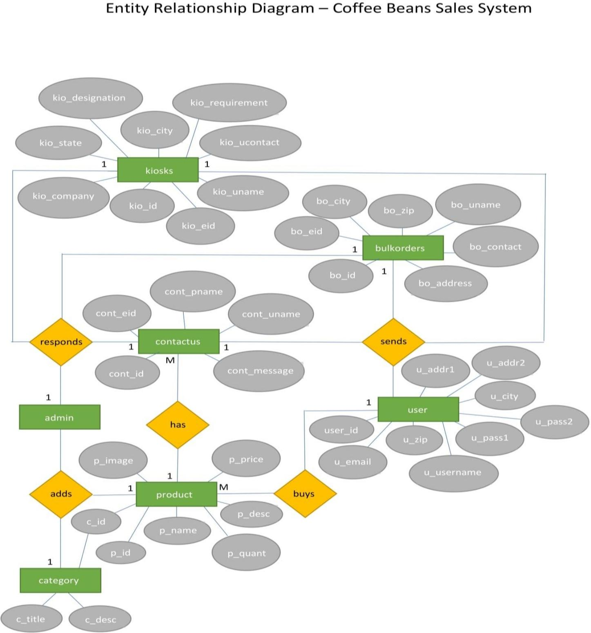

**Sequence Diagram**

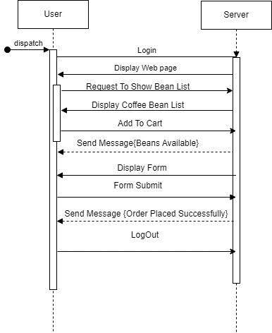

**Class Diagram**

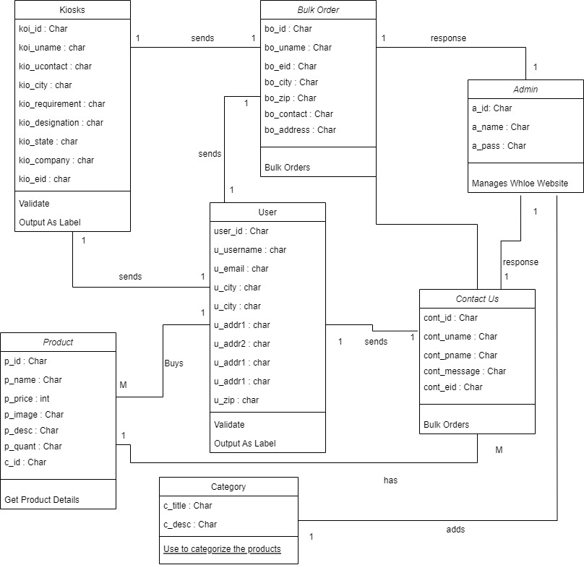

**Use Case Diagram**:

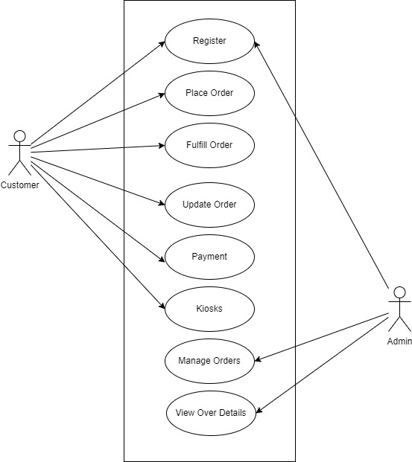

**Activity Diagram**:

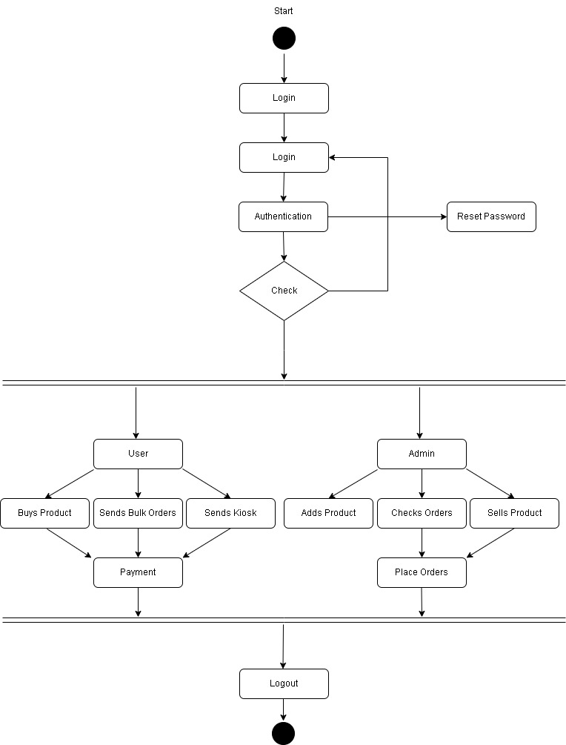

* + 1. DATABASE AND DATA DICTIONARY: -
       - **DATABASE –**

**Table name**: user

|  |  |  |  |  |
| --- | --- | --- | --- | --- |
| **Sr.no** | **Fields name** | **Datatype** | **Width** | **Constraint** |
| 1 | user_id | int | 11 | primary key |
| 2 | u_email | varchar - String | 15 | unique key |
| 3 | u_pass1 | varchar – String | 50 | not null |
| 4 | u_pass2 | varchar – String | 50 | not null |
| 5 | u_username | varchar – String | 50 | not null |
| 6 | u_addr1 | varchar - String | 100 | not null |
| 7 | u_addr2 | varchar – String | 100 | not null |
| 8 | u_zip | int | 10 | not null |
| 9 | u_city | varchar – String | 100 | not null |

**Table name**: product

|  |  |  |  |  |
| --- | --- | --- | --- | --- |
| **Sr.no** | **Field name** | **Datatype** | **Width** | **Constraint** |
| 1 | p_id | int | 11 | primary key |
| 2 | p_name | varchar - String | 50 | not null |
| 3 | p_desc | varchar - String | 150 | not null |
| 4 | p_quant | int | 50 | not null |
| 5 | p_image | varchar - String | 100 | not null |
| 6 | p_price | int | 500 | not null |
| 7 | c_id | int | 100 | foreign key |

**Table name**: contactus

|  |  |  |  |  |
| --- | --- | --- | --- | --- |
| **Sr.no** | **Field name** | **Datatype** | **Width** | **Constraint** |
| 1 | cont_id | int | 11 | primary key |
| 2 | cont_eid | varchar - String | 50 | unique key |
| 3 | cont_pname | varchar | 50 | not null |

|  |  |  |  |  |
| --- | --- | --- | --- | --- |
| 4 | cont_uname | varchar - String | 15 | not null |
| 5 | cont_message | varchar - String | 50 | not null |

**Table name**: bulkorders

|  |  |  |  |  |
| --- | --- | --- | --- | --- |
| **Sr.no** | **Field name** | **Datatype** | **Width** | **Constraint** |
| 1 | bo_id | int | 11 | Primary key |
| 2 | bo_eid | varchar - String | 50 | Unique Key |
| 3 | bo_uname | varchar - String | 50 | Not null |
| 4 | bo_contact | int | 10 | Not null |
| 5 | bo_address | varchar - String | 100 | Not null |
| 6 | bo_city | varchar - String | 11 | Not null |
| 7 | bo_zip | int | 11 | Not null |

**Table name**: kiosks

|  |  |  |  |  |
| --- | --- | --- | --- | --- |
| **Sr.no** | **Field name** | **Datatype** | **Width** | **Constraint** |
| 1 | kio_id | int | 100 | Primary key |
| 2 | kio_eid | varchar - String | 100 | Unique key |
| 3 | kio_uname | varchar - String | 100 | Not null |
| 4 | kio_ucontact | int | 10 | Not null |
| 5 | kio_requirement | varchar - String | 100 | Not null |
| 6 | kio_designation | varchar - String | 100 | Not null |
| 7 | kio_state | varchar - String | 100 | Not null |
| 8 | kio_company | varchar - String | 100 | Not null |
| 9 | kio_city | int | 100 | Not null |

**Table name**: category

|  |  |  |  |  |
| --- | --- | --- | --- | --- |
| **Sr.no** | **Field name** | **Datatype** | **Width** | **Constraint** |
| 1 | c_id | int | 100 | Primary key |
| 2 | c_title | varchar - String | 100 | Unique key |
| 3 | c_desc | varchar - String | 100 | Not null |

* **DATA DICTIONARY: -**

|  |  |  |  |  |  |  |
| --- | --- | --- | --- | --- | --- | --- |
| **SR. NO** | **FIELDS NAME** | **DATA TYPE** | **WIDT H** | **CONSTRAIN T** | **TABLE NAME** | **DATA DESCRIPTION** |
| 1 | user_id | int | 11 | Primary key | user | User id |
| 2 | u_email | varchar - String | 15 | Unique key | user | User email-id |
| 3 | u_pass1 | varchar – String | 50 | not null | user | User password |
| 4 | u_pass2 | varchar – String | 50 | not null | user | Re-enter password |
| 5 | u_username | varchar – String | 50 | not null | user | Username |
| 6 | u_addr1 | varchar - String | 100 | not null | user | User Address 1 |
| 7 | u_addr2 | varchar – String | 100 | not null | user | User Address 2 |
| 8 | u_zip | int | 10 | not null | user | User zip code |
| 9 | u_city | varchar – String | 100 | not null | user | User city |
| 10 | p_id | int | 11 | Primary key | product | Product id |
| 11 | p_name | varchar - String | 50 | not null | product | Product name |
| 12 | p_desc | varchar - String | 150 | not null | product | Product description |
| 13 | p_quant | int | 50 | not null | product | Product quantity |
| 14 | p_image | varchar - String | 100 | not null | product | Product image |
| 15 | p_price | int | 500 | not null | product | Product price |
| 16 | c_id | int | 100 | foreign key | product | Category id |
| 17 | cont_id | int | 11 | Primary key | contactus | Feedback id |
| 18 | cont_eid | varchar - String | 50 | Unique key | contactus | Feedback email |
| 19 | cont_pname | varchar | 50 | not null | contactus | Feedback product name |
| 20 | cont_uname | varchar - String | 15 | not null | contactus | Feedback giver name |
| 21 | cont_messag e | varchar - String | 50 | not null | contactus | Feedback message |
| 22 | bo_id | int | 11 | Primary key | bulkorders | Bulk Orders request id |
| 23 | bo_eid | varchar - String | 50 | Unique Key | bulkorders | Bulk Orders request user email |
| 24 | bo_uname | varchar - String | 50 | Not null | bulkorders | Bulk Orders request username |
| 25 | bo_contact | int | 10 | Not null | bulkorders | Bulk Orders request user contact |

|  |  |  |  |  |  |  |
| --- | --- | --- | --- | --- | --- | --- |
| 26 | bo_address | varchar - String | 100 | Not null | bulkorders | Bulk Orders request user address |
| 27 | bo_city | varchar - String | 11 | Not null | bulkorders | Bulk Orders request user city |
| 28 | bo_zip | int | 11 | Not null | bulkorders | Bulk Orders request user zip code |
| 29 | kio_id | int | 100 | Primary key | kiosks | Kiosk request id |
| 30 | kio_eid | varchar - String | 100 | Unique key | kiosks | Kiosk request user email |
| 31 | kio_uname | varchar - String | 100 | Not null | kiosks | Kiosk request username |
| 32 | kio_ucontact | int | 10 | Not null | kiosks | Kiosk request user contact |
| 33 | kio_requirem ent | varchar - String | 100 | Not null | kiosks | Kiosk request user requirement |
| 34 | kio_designati on | varchar - String | 100 | Not null | kiosks | Kiosk request user designation |
| 35 | kio_state | varchar - String | 100 | Not null | kiosks | Kiosk request user state |
| 36 | kio_company | varchar - String | 100 | Not null | kiosks | Kiosk request user company |
| 37 | kio_city | int | 100 | Not null | kiosks | Kiosk request user city |
| 38 | c_id | int | 100 | Primary key | category | Category id |
| 39 | c_title | varchar - String | 100 | Unique key | category | Category title |
| 40 | c_desc | varchar - String | 100 | Not null | category | Category description |

## USER INTERFACE:

The user interface is based on the web browser. The application is developed using php and html along with CSS. The interface design is aimed at a flexible front-end communication to provide the user with clear information in navigating a user-friendly interface is planned.

* + - INPUT AND OUPUT SCREENS –

## User Module:

* 1. Welcome Page

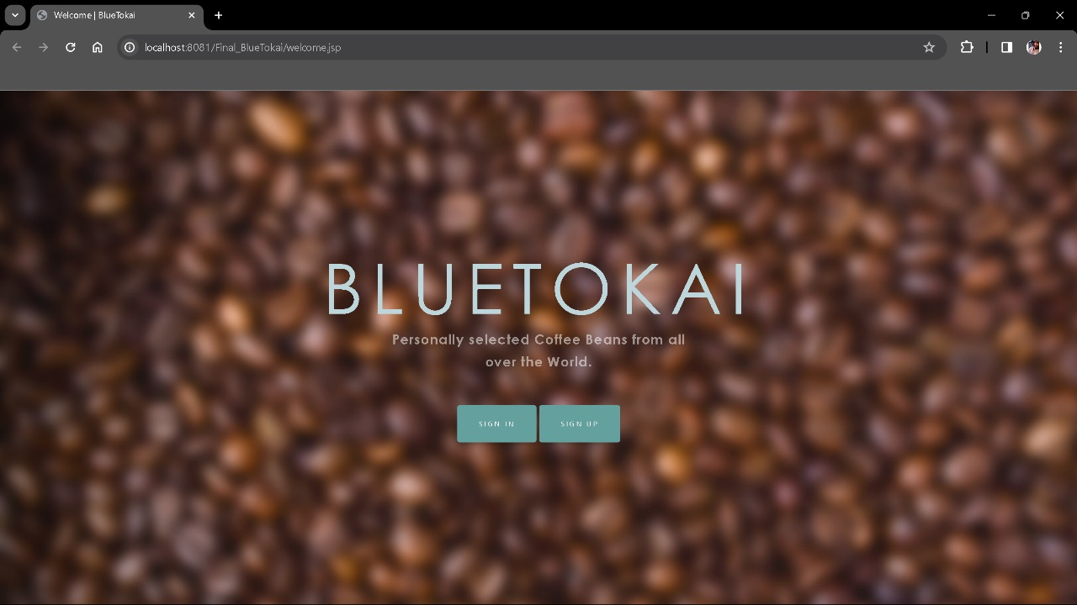

## Sign in Page

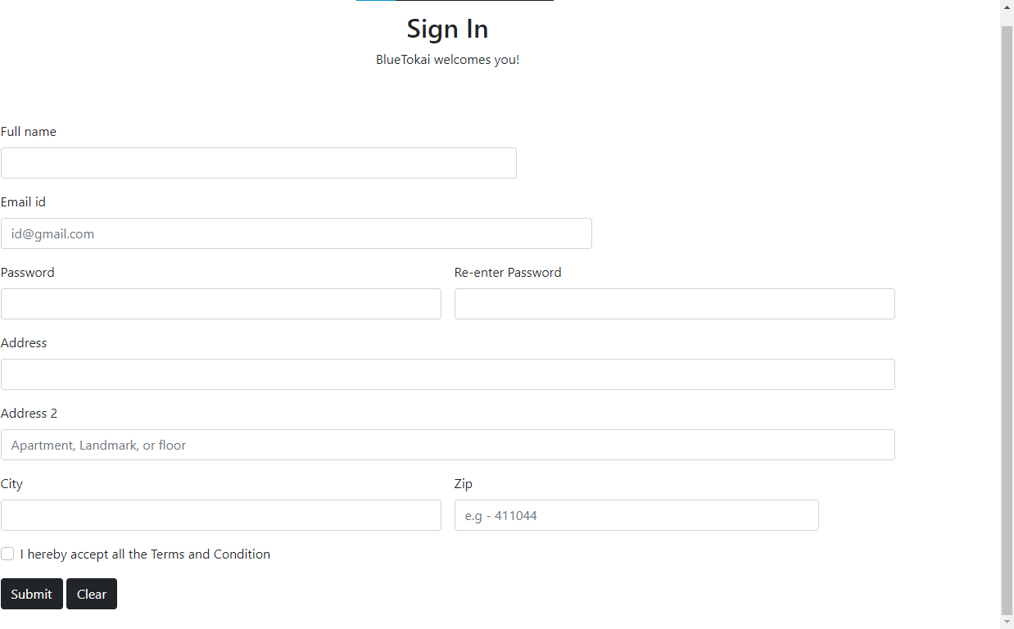

* 1. Sign in Page Validations

## Field required validation

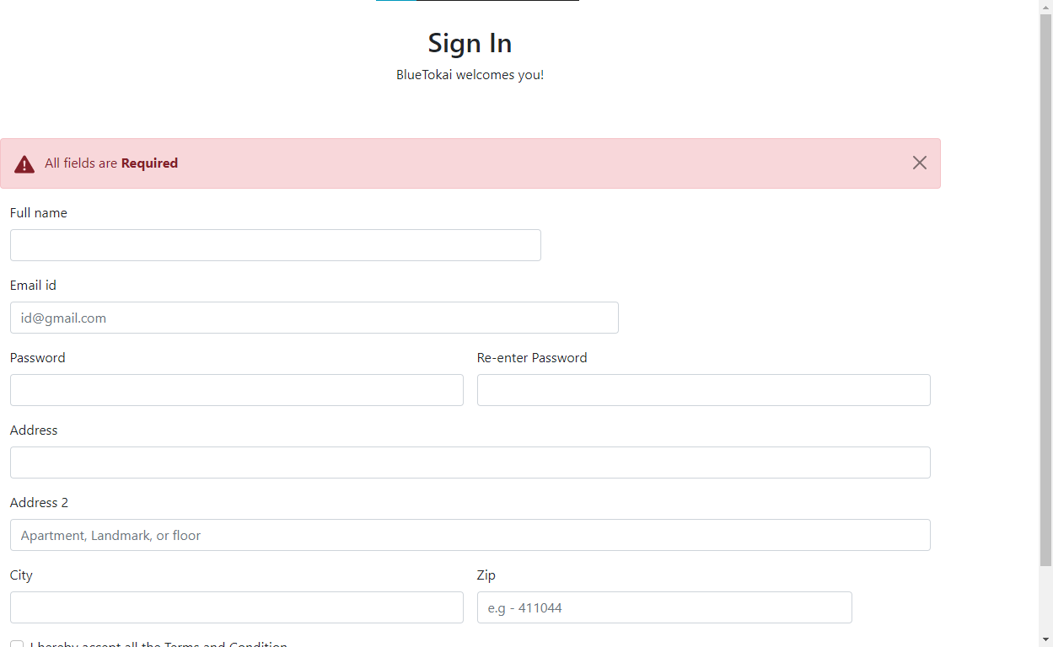

* + 1. Registered Successful validation

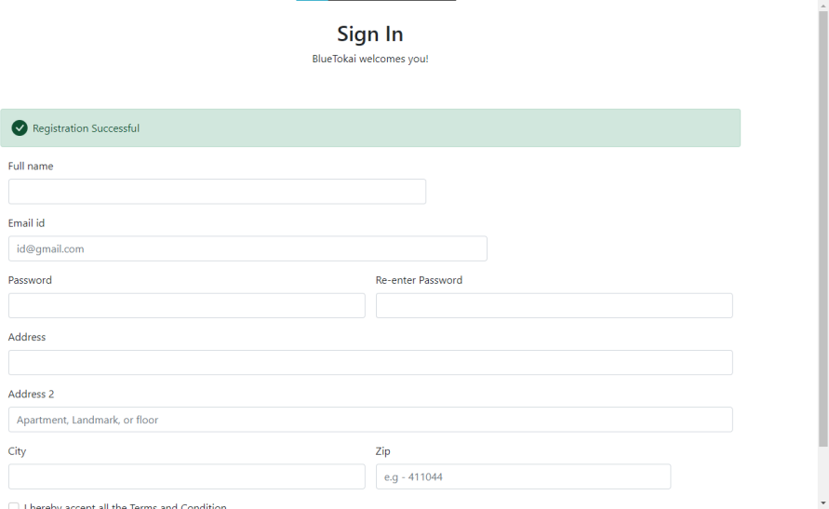

## A screenshot of a computer Description automatically generatedLogin Page

* 1. Login Page Validations

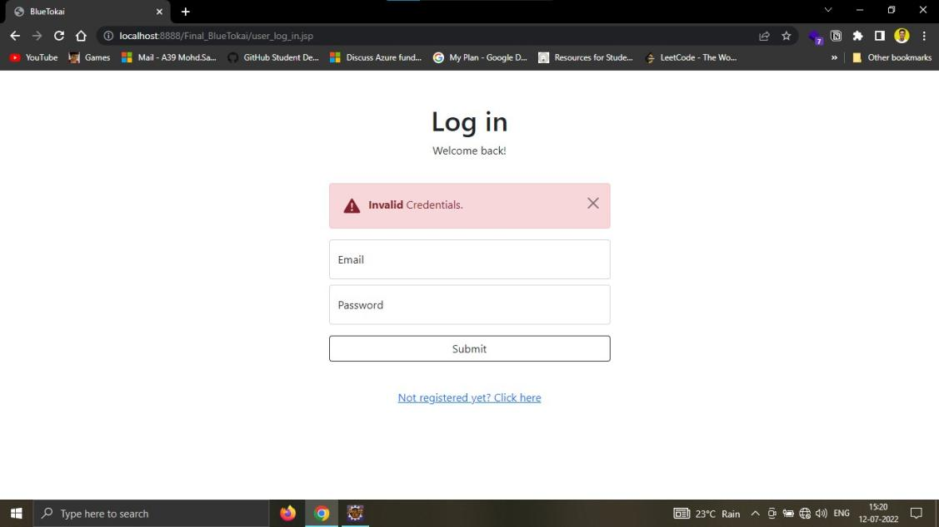

## Graphical user interface Description automatically generatedAfter Login Page – Index Page

* 1. Product Browsing

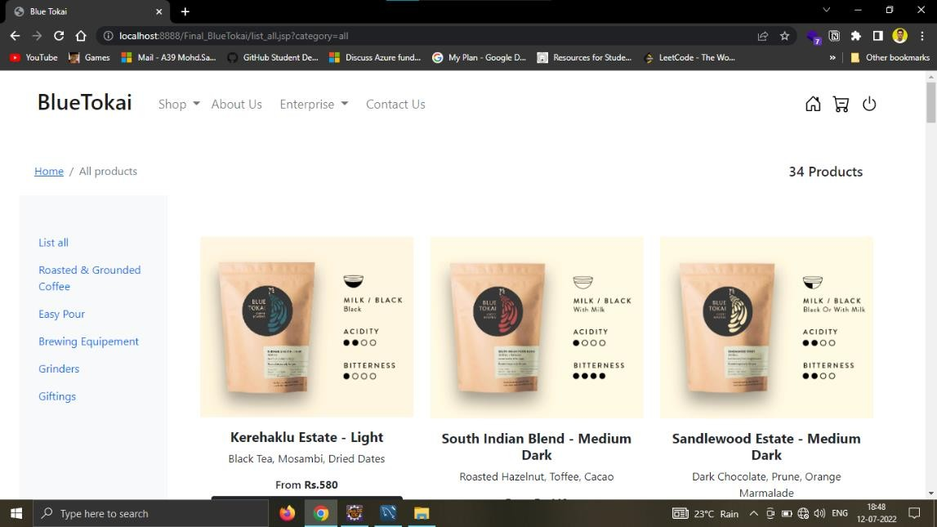

## Graphical user interface Description automatically generatedBulk Orders Enquiry page

* 1. Bulk Orders Enquiry Page Validations

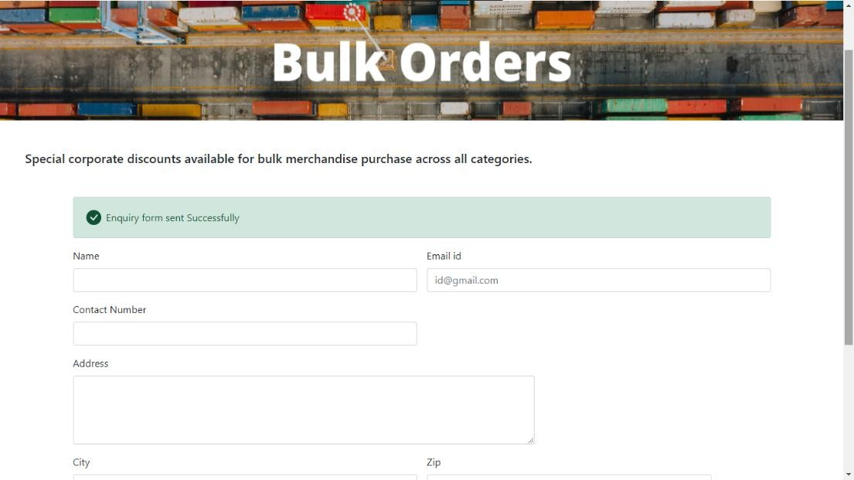

## Graphical user interface, text, application, email Description automatically generatedKiosk Enquiry Page

* 1. Kiosk Enquiry Page Validations

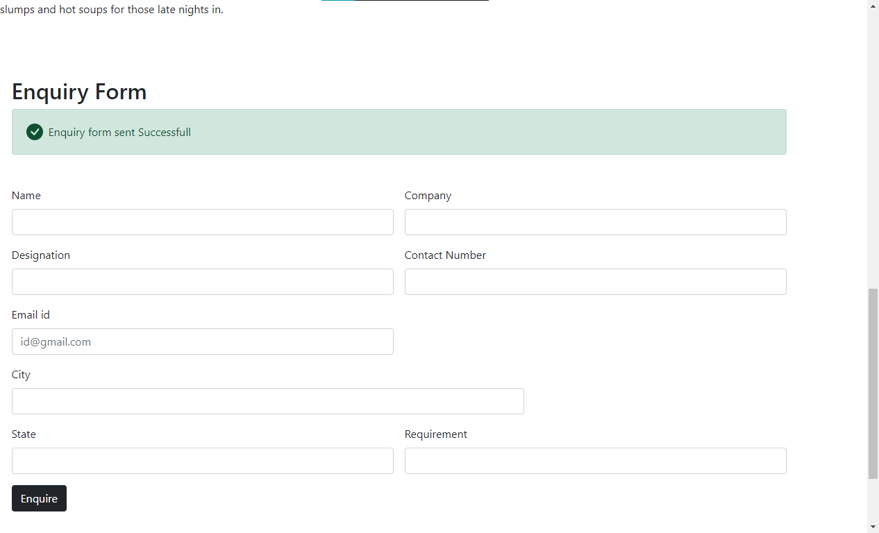

## Cart Page

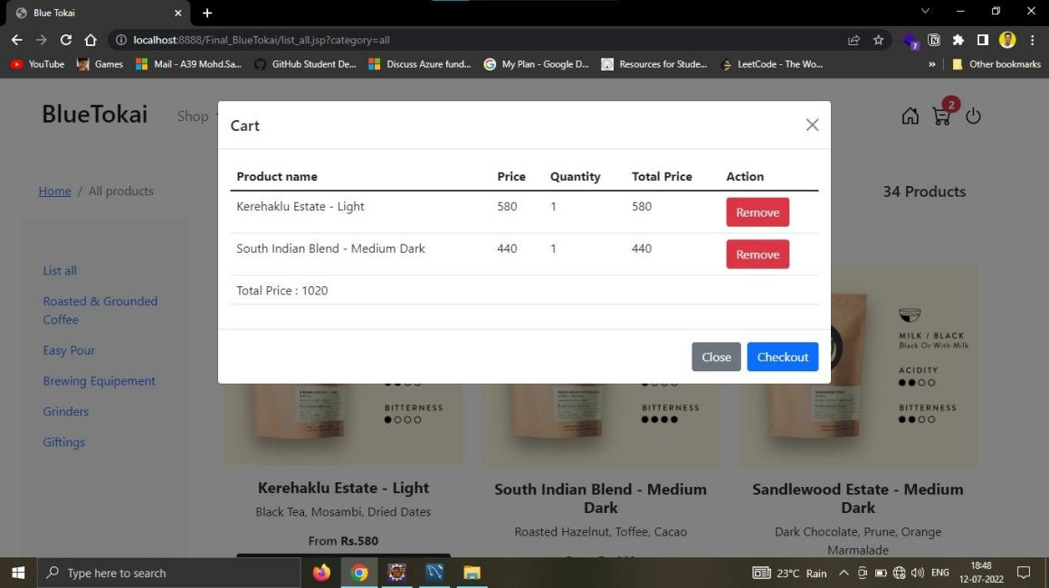

* 1. Checkout Page

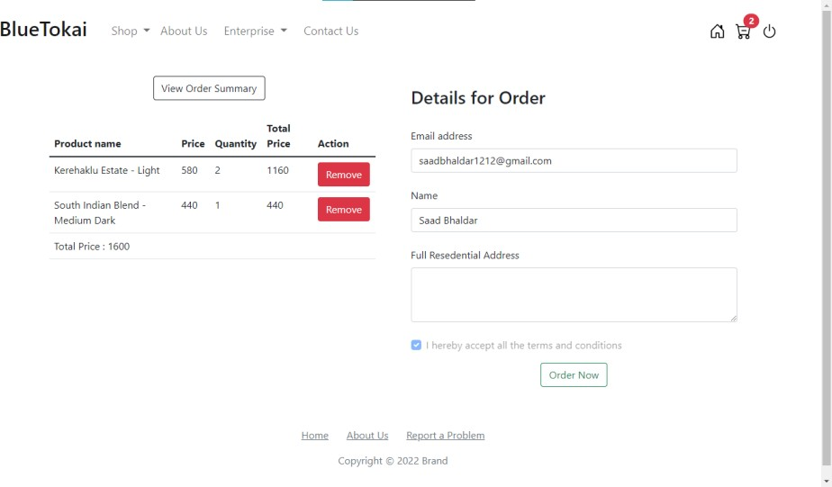

## A screenshot of a computer Description automatically generatedFeedback Page

* 1. Feedback Page Validations

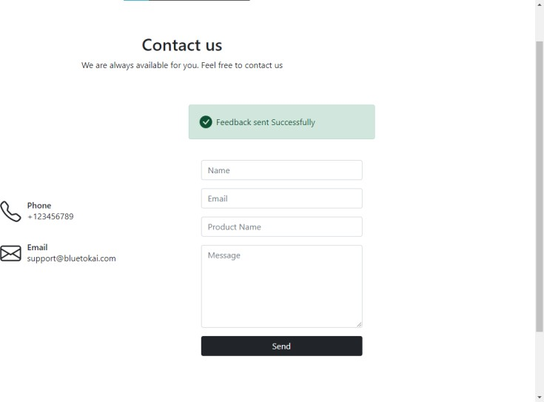

## Admin Module:

* 1. Admin Login Page

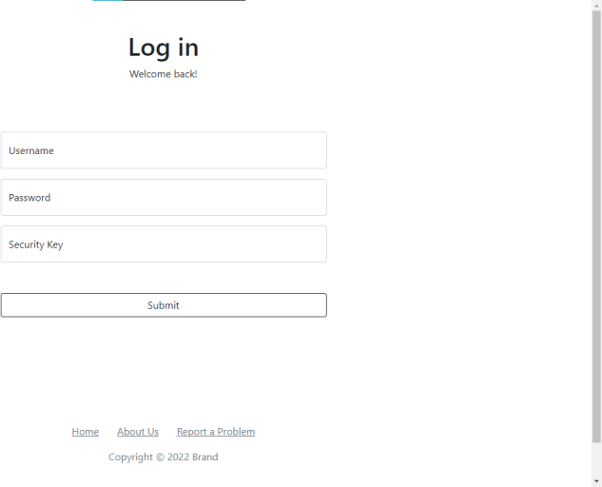

## Admin Login Page Validation

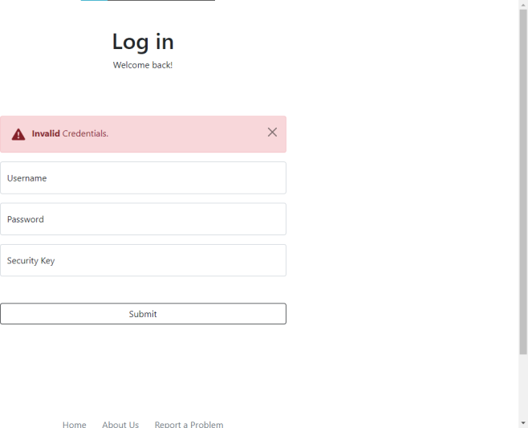

* 1. Admin After Login Page

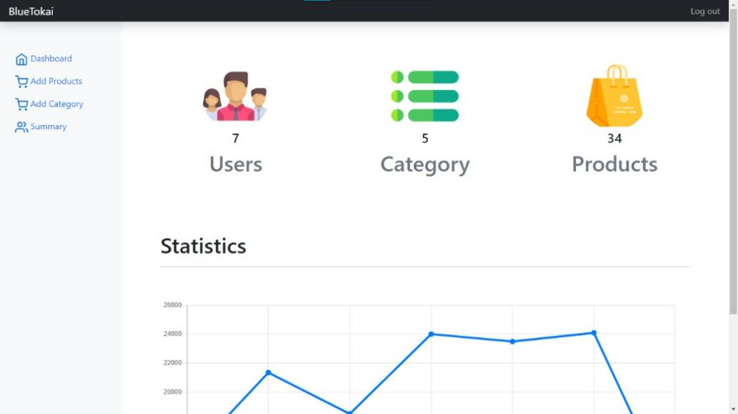

## Add Product page

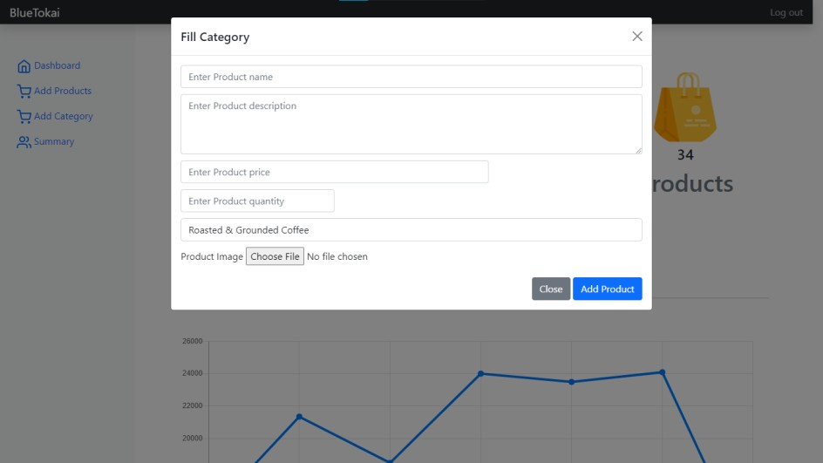

* 1. Add Category

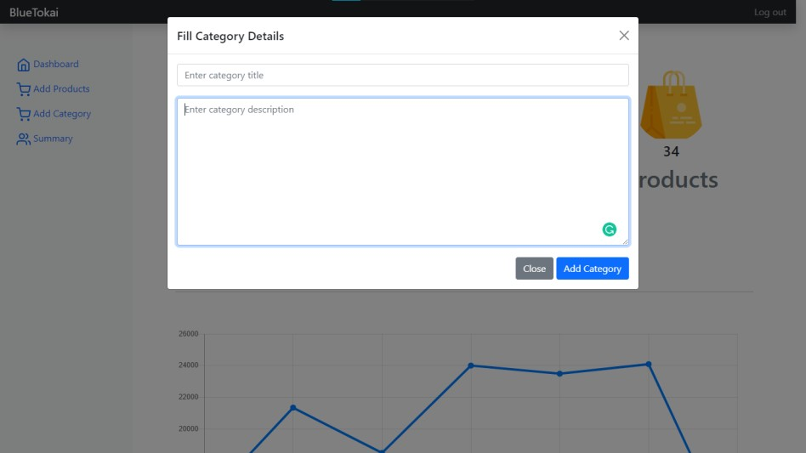

# IMPLEMENTATION DETAILS:

The user needs to enter his or her information required in the signup page. The page allows the user to enter the login page of the user. This is done using JSP programming. The usage of HTML, CSS to work register these data collected. To avoid the redundancy of the data MYSQL-Hibernate can be used. This allows more faster and simple access of their data.

HTML is used to design the site aesthetics and simplicity of the site using CSS. MySQL is used as a database to the data stored in the site, JavaScript is linked between the front and the back end.

Hardware is an essential requirement in the development of the system to build the system. To do so a moderately good system is required. And software like Eclipse IDE, Apache Tomcat Server, MySQL-Workbench etc., to create this site.

* SOFTWARE AND HARDWARE REQUIREMENTS -

|  |  |
| --- | --- |
| **Software Requirement** | |
| Operating System | Microsoft Windows |
| **Software: -** | |
| Front - End Software | Apache Tomcat Server |
| Back – End Software | MySQL |
| **Hardware Requirements** | |
| Processor: | Intel core i3 2.00GHz |
| RAM: | 4GB or more |
| Monitor: | LCD Monitor |
| Keyboard: | Normal Keyboard |
| Mouse: | Compatible mouse |

# OUTPUT AND REPORT TESTING:

## TEST PLAN:

Software testing is a critical element of software quality assurance and represents the ultimate review of specification, design, and coding. Testing presents an interesting anomaly for the software engineer.

1. Testing is process of executing a program with the intent of finding an error.
2. A good test case design is one that has a probability of finding a yet undiscovered error.
3. A successful test is one that uncovers a yet undiscovered error.

These above objectives imply a dramatic change in view port.

Testing cannot show the absence of defects, it can only show that software errors are present.

|  |  |  |  |  |
| --- | --- | --- | --- | --- |
| Sr.no. | Test case | Input tag | Description | output |
| 1 | Name | Textbox | Only characters are accepted. | If only characters are there,  then correct otherwise incorrect. |
| 2 | City | Textbox | Only characters are accepted | If only characters are there, then correct otherwise  incorrect. |
| 3 | Address1 | Text area | Enter your address1 | Correct |
| 4 | Address2 | Text area | Enter your address2 | Correct |
| 5 | Phone number | Textbox | Only 10-digit numbers are accepted. | If only digits (0 to 9) are there, then correct otherwise  incorrect. |
| 6 | Email | Textbox | This accepts characters in upper as well as in lower case, digits, and special symbols also. | Correct |

|  |  |  |  |  |
| --- | --- | --- | --- | --- |
| 7 | Zip | Textbox | Only characters are accepted | If only characters are there, then correct otherwise  incorrect. |
| 8 | Password | Textbox | This accepts characters in upper as  well as in lower case, digits, and special symbols also. | Correct |
| 9 | Re-enter  Password | Textbox | Should be same to the password. | Correct |

# CONCLUSION AND RECOMMENDATION:

The online shopping system covers the various issues. These are as follows: -

* Data is secure and easy to retrieve, store, and analyze, so chances of miscalculations and occurrence of error are very less.
* In existing traditional and manual system, the chances of error occurrence would be very high, but this being an online computerized application, gives users alert messages, helps, and warnings on whatever required or requested.
* It saves times for customer.
* It is convenient way of shopping.
* It is available 24x7 manners.
* It is true that human made mistakes as a computer are always accurate.
* There is a separate database records stored in a hard disk.
* It provides most secured way for shopping.
* Easy to generate daily sales reports.
* Easy to check the available stock of products.
* User friendly GUI.

# FUTURE SCOPE:

Though our project is itself matured enough but still betterment is always an open door. In this case also we can add some features to this software to make this software more reliable.

## These are as follows:

* Firstly, a payment module for making real time payments
* Secondly, modify the project with better approach with more graphics.
* Thirdly, a track package module for making it more user-friendly
* Fourthly, the back-up procedure can be incorporated to make sure of the database integrity.

# BIBLIOGRAPHY AND REFERENCES:

1. [JSP Example in Eclipse - javatpoint](https://www.javatpoint.com/creating-jsp-in-eclipse-ide)
2. [Introduction to JSP - GeeksforGeeks](https://www.geeksforgeeks.org/introduction-to-jsp/)
3. [HTML & CSS Courses & Tutorials | Codecademy](https://www.codecademy.com/catalog/language/html-css)
4. [www.wikipedia.com](http://www.wikipedia.com/)
5. [www.htmlcodetutorial.com/](http://www.htmlcodetutorial.com/)
6. [www.tutorialspoint.com](http://www.tutorialspoint.com/)
7. [www.w3schools.com](http://www.w3schools.com/)